**BabyCare Project**

1. **Introduction:**

A software product which provides solution for baby health, baby food, baby tips, baby products, baby names, parenting etc. Here, user can view baby names, baby names by religion, baby tips, baby food and baby product. Admin can add and delete baby names.

1. **Project Description:**

It is an approach for better upbringing of a child. This baby care project revolves around everything that is needed to be taken care of after a child’s birth. The developers have built this site with every detail like which food to provide to a child, what medicine to provide at which age, baby products, and tips about taking care of a baby and etc. This site also provides suggestions of really good names for the babies and this also have a feature name parenting where there are a lot of tips for the parents responsible for the baby.

This project revolves around two modules- admin and user. The admin module deals with the administration work of the site. The functionality of the admin is that the person registered as admin mainly the developers can add new baby names for the users, update or delete any names from the sites. They can also add new pages to the sites add on functionalities. They are responsible for giving a constant update about baby care. The user module deals with the registered people to the site. The registered users have to provide all the details about their newborn baby and the system will provide them with information about everything. The registered user gets all the information from here about baby tips, baby food, and also about parental behaviour around the newborn.

1. **Developer Details:**

My name is Pooja Prathemesh Warang, graduated in 2019 as a Computer Engineer from Womens BCA collage in Sawantwadi,Sindhudurg and now I am doing external MCA in YCMOU,Nashik

This project is a practical implementation of some of the languages and technologies which I have been learning,such as HTML, CSS, JSP, Servlets ,JAVA and JDBC.

### III. **User Interface Priorities**

1. Professional look and feel
2. Use of with all registration forms and with every search option and at the id of each searched result with on mouseover event.

Requirements:

* Operating system:-

Windows 10

* Front-end:-

Html, CSS, JSP, Java

Eclipse-Java EE

* Back-end:-

MY SQL Workbench

JDBC

### **Users of the System**

1. Admin
2. Users

### **Functional Requirements**

**1. Admin**

1. Can login and logout.
2. Can add baby names.
3. Can view baby names.
4. Can delete baby names.
5. Can add new pages.

**2. Users**

1. Can view baby names.
2. Can view baby tips.
3. Can view baby food.
4. Can view baby products

### **How to run this project**

* Import the SQL file in MySQL (located in Web-Content directory)
* Paste mysql-connector.jar file inside lib directory.
* Import the project on the Eclipse IDE and run it.

### **Password for Admin**

Username is **admin** and password is **admin123**.

### **Welcome Page**

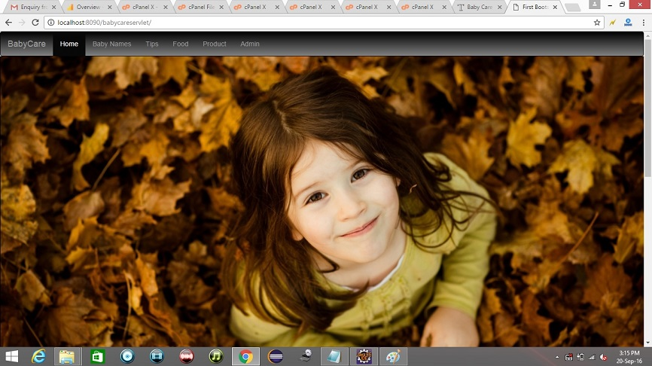 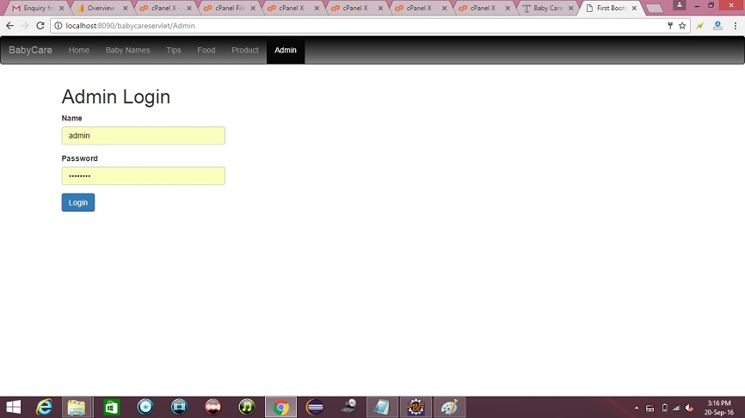

1. **Conclusion:**

BabyCare Servlet Project is about Parenting is definitely not an easy task, to begin with. Most of the people are totally clueless about this subject. They hardly have any idea of how to take proper care of a newly born baby. Most of them get scared and try to imitate other parents by hearing from them without knowing if it is really good or bad for the child. Due to the lack of information, this occurs. And even if we seek doctor help it’s impossible to ask a doctor so many questions within a limited span of time of appointment. So keeping this idea intact the developers had built this project using JSP, JAVASCRIPT, AJAX, and JDBC which deals with everything needed for the welfare of a newborn child also including parental behaviour.